**NHS preparation for implementation of the Liberty Protection Safeguards (LPS)**

April 2021

**Foreword**

Professor Keith Brown

Independent Chair of Safeguarding Adults National Network

The Mental Capacity (Amendment) Act 2019 introduces the Liberty Protection Safeguards (LPS). The new system will provide protection for people aged 16 and over who may need to be deprived of their liberty in order to enable their care or treatment and lack the mental capacity to consent to these arrangements.

This publication provides information that can be shared within health services so they can prepare for the implementation of LPS in April 2022. The legislation will create new roles for CCG/ICS’s and NHS Trusts in authorising the arrangements, and with less than a year to go it is imperative that system leaders ready their organisations for the changes. I would like to express my sincere thanks to David Pennington and Sharon Thomson for taking the time with other SANN members to produce this guidance. It is both timely and informative to the sector. SANN exists as a community of practice and interest to serve its members in the promotion of the best quality safeguarding practice so that ultimately citizens can live lives free from abuse and exploitation.

**Authors**

David Pennington, Designated Professional Safeguarding Adults for North Central London CCG based in Islington, has worked for in the NHS for over 20 years. This has included an appointed to the National team responsible for implementing the Mental Capacity Act and Deprivation of Liberty Safeguards and led this work in the South West region.

Sharon Thompson Designated Nurse Safeguarding Adults in South Tyneside CCG has worked within the NHS in both mental health and acute health providers and Clinical Commissioning for over 36 years.She welcomed the Mental Capacity Act 2005, (MC(Amendment)A 2019) with its strength based in human rights, she was one of the first emerging Mental Capacity Act leads in an Acute health Trust and became a Best interests Assessor for Deprivation of Liberty Safeguards.

**Purpose**

The purpose of this guide is to explain changes significant to the NHS resulting from the Mental Capacity (Amendment) Act 2019 (MCAA), which introduces the Liberty Protection Safeguards (LPS) scheme. It should be noted that this guide is subject to change, and is not a replacement for receiving your own legal guidance

**Introduction**

The right to liberty is enshrined through Article 5 of the European Convention of Human Rights (ECHR), incorporated into domestic law by the Human Rights Act 1998 (HRA). An individual should only be deprived of their liberty (DoL) through a lawful procedure, for example that related to the criminal justice process or the Mental Health Act (1983, as amended in 2007), and subject to appropriate procedural safeguards, including a right to challenge that DoL.

In the health and care context, a person is regarded as deprived of their liberty if;

* the person lacks mental capacity to consent to their accommodation for the purposes of care/ treatment
* the care amounts to “continuous supervision and control” and they are “not free to leave” (in the sense of being able to go to live somewhere else)
* the care arrangements are attributable (in whole or in part) to the state (which will include any case where the NHS or local authority is involved in providing or commissioning the relevant care, or is aware of it).

This is called the “acid test” from the Supreme Court case of *Cheshire West*, which was in the context of long-term residential care placements. The Court of Appeal (in *Ferreira*) has held that it should not be applied literally to the different context of provision of life-saving medical treatment in hospital, but the way this should work in practice, alongside MCAA reforms to the law for emergency situations, will be addressed in the Code of Practice.

When it appears that there is a deprivation of liberty, this must be scrutinised and, if appropriate, authorised through a lawful procedure, primarily to allow the person to exercise their rights under the ECHR / HRA. The purpose is not only to legally authorise the deprivation of liberty but also to ensure that those deprived of their liberty benefit from the safeguards that accompany the authorisation.

The Deprivation of Liberty Safeguards (DoLS) system is the current authorisation arrangements for adults (i.e. over 18 years) either residing in a care home or hospital. The Court of Protection directly authorises all other deprivations of liberty not covered by DoLS, including those in community settings, as well as young people aged 16-17.

The LPS will replace these existing processes, to authorise a deprivation of liberty for patients over the age of 16, in any setting. The Court of Protection will still have a role in some cases, as well as providing a route to appeal against the use of the LPS.

The draft timetable (which may be subject to change) for implementation anticipates the following (based on DHSC planned milestones for LPS):

|  |  |  |  |  |
| --- | --- | --- | --- | --- |
| **Jan 2021** | **Spring 2021** | **Winter 2021** | **1st April 2022** | **April 2023** |
| Further interim Impact assessment publication[1] | Draft Code of Practice and Regulations consultation | Publication of finalised Code of Practice and Regulations | LPS goes live | DOLS arrangements come to an end |
| Applications to Deprive of Liberty continue under DOLS arrangements | | | All new applications will be made under the LPS. Existing DOLS authorisations will run in parallel until April 2023 to aid transition to LPS | |

The government has confirmed it aims to implement the MCAA on the 1st April 2022, when any new applications must be made under LPS rather than DoLS. An accompanying Code of Practice and draft Regulations are expected to be presented for consultation in spring 2021.

Existing DoLS authorisations already in place on 1 April 2022 can last for up to one year, so will continue to run alongside new LPS for up to a year to support an effective transition between the old and new schemes.

**Key aspects of the new LPS;**

* LPS to be applicable in all settings, including domestic settings such as a family home or supported living.
* LPS not tied to accommodation or residence, can be used to authorise an overall care plan including day centre, respite and transport arrangements
* LPS to include 16- and 17-year old’s (though the new Clinical Commissioning Group (CCG) / Integrated Care System (ICS) responsibilities are for patients who are Continuing Healthcare (CHC) funded, i.e. only over 18 years)
* New “Responsible Body” (currently under DoLS only local authorities, called the Supervisory Body) role extended to CCGs/ICSs and Hospital Trusts (including NHS Foundation Trusts)
* New responsible bodies will be responsible for organising assessments, pre authorisation reviews, authorising any deprivation of liberty and monitoring.
* Reducing the existing 6 DoLS assessments to 3 – mental capacity assessment, medical assessment, and a ‘necessary and proportionate’ assessment; these may be embedded into existing care planning, with previous DoLS assessment requirements moving to a fact-finding process
* New role of Approved Mental Capacity Professional (AMCP) instead of the role of the current DoLS Best Interests Assessor (BIA) – likely to be first tier nurses, occupational therapists and social workers, awaiting regulations, with the AMCP to be involved only in certain cases, rather than the BIA in every DoLS case
* AMCP completes pre-authorisation review where an objection has been raised, in independent hospital cases or other relevant (complex) cases as set out in the Code of Practice – will meet with person, complete consultation and look at information relied upon for assessments
* Qualified staff to undertake most of LPS assessments, to be completed as part of routine care or Care Act Assessment
* No need for DoLS Mental Health Assessor / section 12 Doctor – evidence of mental disorder can be obtained more flexibly and from wider sources than under DoLS, however if not known a doctor’s assessment is likely to be needed.
* Explicit duty to consult with carers and families, as well as the patient
* People are supported throughout the process by an ‘appropriate person’; with an Independent Mental Capacity Advocate (IMCA) appointed if no such person available
* Signing off LPS assessment involves pre-authorisation review and then authorisation
* An amended Mental Capacity Act s4B will replace DoLS urgent authorisations by providing that a patient can be deprived of their liberty to carry out life sustaining treatment or a vital act, while an LPS authorisation or a Court application is made, or in any case in specified “emergency” circumstances. (The way this relates to the *Ferreira* judgment that life-saving medical treatment is generally not regarded as a DoL at all will need to be clarified in the Code of Practice)
* Option to extend the period of DoL to be authorised for individuals with long term stable conditions from one year (the maximum under DoLS) to up to three years on the second renewal

The policy intention behind the reforms is to promote the consideration of deprivation of liberty within mainstream care planning, making consideration of LPS part of everyday care. It does this by giving NHS Trusts and CCG/ICS’s, in addition to local authorities, a specified responsibility in authorisations.

Under the LPS, there is one responsible body for each authorisation that is granted. In order to identify the responsible body in any given case, the legislation creates the following responsibilities:

* If the arrangements are carried out mainly in an NHS hospital, the responsible body is the “hospital manager”, which would in most cases be the NHS Trust that manages the hospital.
* If the arrangements arecarried out through the provision ofNHS Continuing Healthcare (CHC) for adult patients, the responsible body is the relevant CCG/ICS.
* In all other cases (including in patient care in an independent sector hospital) the responsible body is the “local authority” (in most cases this will be the authority that is meeting the person’s needs or in whose area the person is ordinarily resident).

The regulationof the CCG/ICS role as a responsible body is likely to be undertaken by the Care Quality Commission (CQC). This will mean that CQC may inspect CCG/ICS’s for this activity, although details of precisely how the LPS will be regulated are still to be confirmed.

**Implications for the NHS of LPS**

Notably the current supervisory body of the Local Authority will shift to the hospital Trust in those cases where someone is in an NHS hospital[2] or to the CCG / ICS where their care is funded by Continuing Health Care (CHC).

The other significant shift is the lowering of the age at which the safeguards apply. The case of D (A Child) 2019 UKSC 42[3] has confirmed that if a 16 or 17-year-old is deprived of their liberty it is not sufficient to rely on the consent of someone with parental responsibility. It is important to note that the case clarifies that in order to deprive of liberty someone aged 16-17, an application to the Court of Protection is ***currently*** required. Organisations should not wait until the implementation of LPS before acting on this[4].

Whist a community LPS authorisation will likely form part of the LA’s responsibility, health care services around the person may be engaged in assessments, care planning arrangements and that any DoL was necessary and proportionate.

CCG/ICS’s and NHS Trusts will need to:

* Ensure relevant staff are aware of the new arrangements
* Provide systems for applying LPS
* Introduce mechanisms for monitoring LPS
* Have access to suitable trained staff to authorise the application (Appendix 2) including
  + Pre-authorisation reviews
  + Medical assessments
  + Approved Mental Capacity Act Professionals
* Access the IMCA service

Whilst the NHS may need staff to undertake the role of the AMCP, approval of these roles will be the responsibility of the Local Authority (although the AMCP is able to be employed within the responsible body NHS Trust).

**Hospitals**

Where care which amounts to a DoL is provided in an NHS hospital, the hospital will be the responsible body. This will apply to anyone over the age of 16.

Life-sustaining treatment or a vital act can generally be carried out (under an amended MCA s4B) where it is reasonably thought that the patient lacks capacity for the relevant decisions, that they are in his / her best interests and that they are necessary and proportionate, whilst waiting for a decision from the LPS responsible body or the Court of Protection, or in an emergency when such steps are necessary and there is no time to go through LPS or to the Court.

Independent Hospitals, such as Hospices will need to apply to the Local Authority who will be the responsible body

**CCG/ICS’s**

If a patient is funded by CHC, the responsible body will be the CCG/ICS. For those who meet the criteria for CHC (i.e. over the age of 18) the application will be made to the CCG/ICS (except where that patient is admitted to an NHS hospital).

Where a patient is not in an NHS hospital or in receipt of CHC the responsible body will be the Local Authority.

**National work being undertaken**

There are a number of national workstreams looking at different aspects of the LPS including:

* Forms, coding and data sets collection including clinical system providers
* Training materials in co-ordination with Health Education England
* The draft Code of Practice and Regulations are currently being considered against the proposed changes for CCGs and ICS by the DHSC

Appendix 1

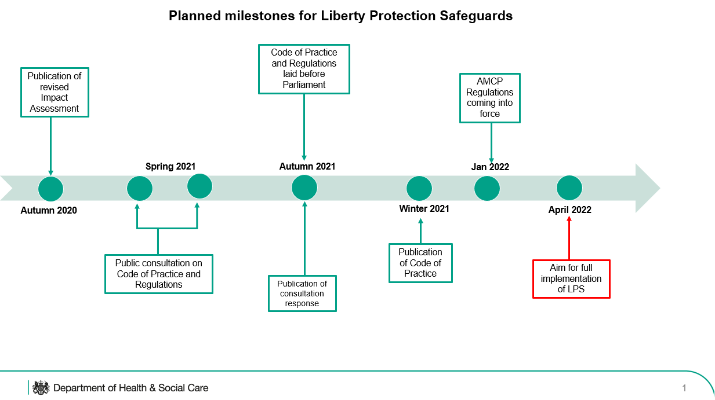

Appendix 2

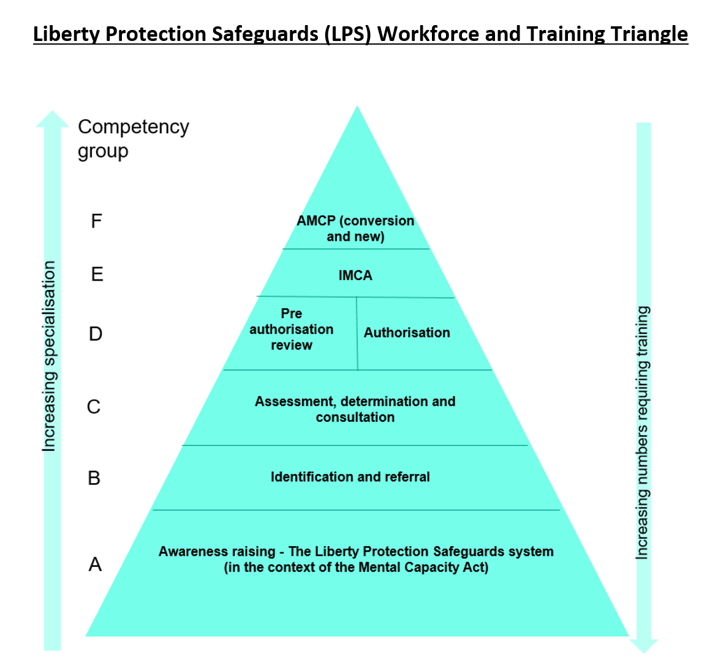

**Competency Group A** All stakeholders in health, care, education and other services, who may encounter a person who might lack the capacity to consent to arrangements that may give rise to a deprivation of their liberty, and who require general awareness of the Liberty Protection Safeguards, the wider Mental Capacity Act.

**Competency Group B** Supervisors and managers, who may need to identify when a person may be deprived of their liberty, so that authorisation may be required under the Liberty Protections Safeguards, and know how to make a referral for the relevant assessments to be done.

**Competency Group C** All roles that under the regulations might undertake assessments, determinations and consultation on behalf of a Responsible Body, within the Liberty Protection Safeguards process

**Competency Group D** Managers in Responsible Bodies who might undertake Pre-authorisation Reviews or authorise deprivation of liberty under the Liberty Protections Safeguards on behalf of the Responsible Body

**Competency Group E** Existing and new Independent Mental Capacity Advocates (IMCAs)

**Competency Group F** People who meet the requirements set out in regulations, to undertake full approved mental capacity professional (AMCP) training, or best interests assessor (BIA) to AMCP conversion training and to be approved as an AMCP by the relevant local authority (regardless of who employs them) in line with the relevant regulations.

1. https://www.gov.uk/government/publications/impact-assessment-of-the-mental-capacity-amendment-act-2019
2. The exception to this is private hospitals where the Local authority will continue to be responsible body for authorising LPS. Currently this is likely to include Hospices.
3. <https://www.mentalcapacitylawandpolicy.org.uk/re-d-the-supreme-court-16-17-year-olds-and-confinement/>
4. There may equally be some cases of a child under the age of 16 for whom a DoL can only be made lawful by the Court and an application must be made urgently.