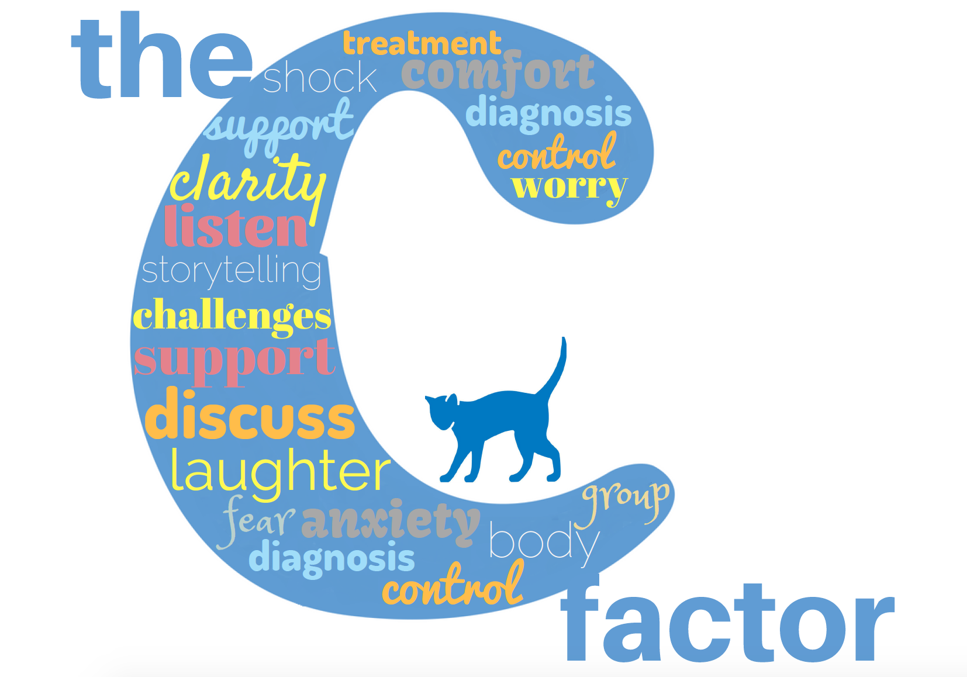

**The C Factor:**

**Storytelling sessions about the Emotional Effects of Cancer**

**Some Information for Participants**

This programme started in September 2018, using a fun and different storytelling approach.

The sessions aim to give participants an opportunity to acknowledge as a group the many challenges they face when going through cancer. By looking at these as a group, we believe that group members can support and learn from each other.

The sessions offer some psychological tools and hints to help with managing the emotional challenges of living with cancer.

**Thank you** for volunteering to help us to develop these sessions. Your feedback will help us to provide appropriate support to future cancer patients. We hope you find the sessions useful and enjoyable.

**Eight Sessions** (every 2 weeks - with some variation):

**The Story**

The story of Ricky and his friends is told by actor Adam McGuigan from **‘Wake the Beast’** arts company. Ricky and his friends are fictional characters, but most of their stories are the real experiences of Whittington patients who took part in the background research for the project.

The C Factor team wish to thank this generous group of patients who helped us to develop the sessions.

**Your Feedback**

This programme is always in development. We will ask for your comments and feedback throughout the programme. The more feedback you can give us, about what you like and don’t like, what is helpful or not helpful, etc. the better we can develop the sessions for the future, and the more chance we have of being supported to keep running the programme.

**Who is the C factor for?**

* + For people with a diagnosis of cancer under the treatment of the Whittington hospital.
  + For those who have not received one to one support from the cancer care psychology service.
  + Not for people who are hoping for one to one support with a psychologist – if you would like this, please let us know or ask a member of the medical team.
  + For people with any type of cancer, and at any stage – from newly diagnosed to post treatment and people with advancing disease.
  + For people with an open mind to a new and different approach.
  + For people who can try to commit to at least 4 of the 8 sessions – for continuity and learning, and to get to know the other participants.

**Respect for others and respect for ourselves**

We ask everyone to respect each other’s privacy by not talking about others’ experiences outside the sessions. However, we cannot guarantee this. So we ask you to only share what you feel safe and comfortable talking about in a group setting.

**Allergies -** Afternoon tea is provided, but we cannot always guarantee products to be allergen free. Please let us know if you have any allergies.

If you have any questions, please contact us.

Tracey Palmer: 07881 834433 or 020 7288 5305, Sue Gibbons: 07557 426791

Email: [sue.gibbons4@nhs.net](mailto:sue.gibbons4@nhs.net) or [traceypalmer@nhs.net](mailto:traceypalmer@nhs.net)

*We hope you enjoy being a part of The C Factor*