LGBTQIA+ Awareness Training Module
45 mins development
Complete this learning log as a record of your thinking

Individual Learning Module

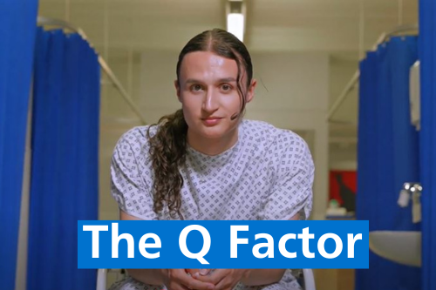
Name ……………………………………………………………………………..
Date training completed ……………………………………………………
My Objectives

- What do you think discrimination against LGBTQIA+ people looks like in the NHS?
  - Do you think it is always deliberate?

Reflections about the Film
- What is your response to the film?
- What were some of the events that you observed that had a negative impact on the 3 patients?
- How do you think the 3 patients felt because of these events?

Reflections About your own Experience
- From your own experience or observation what challenges might LGBTQIA+ patients encounter when interacting with the NHS/social care?
- What examples do you have from your own department/practice?

Turning Insight into Action
- Thinking about your own department/practice, how can you apply your insights to the interactions that you have with LGBTQIA+ patients?
    - What is already in place?
    - What additional measures could be implemented? How might these changes positively impact LGBTQIA+ patients?
- What will you personally do differently as a result of this training?

Key Messages
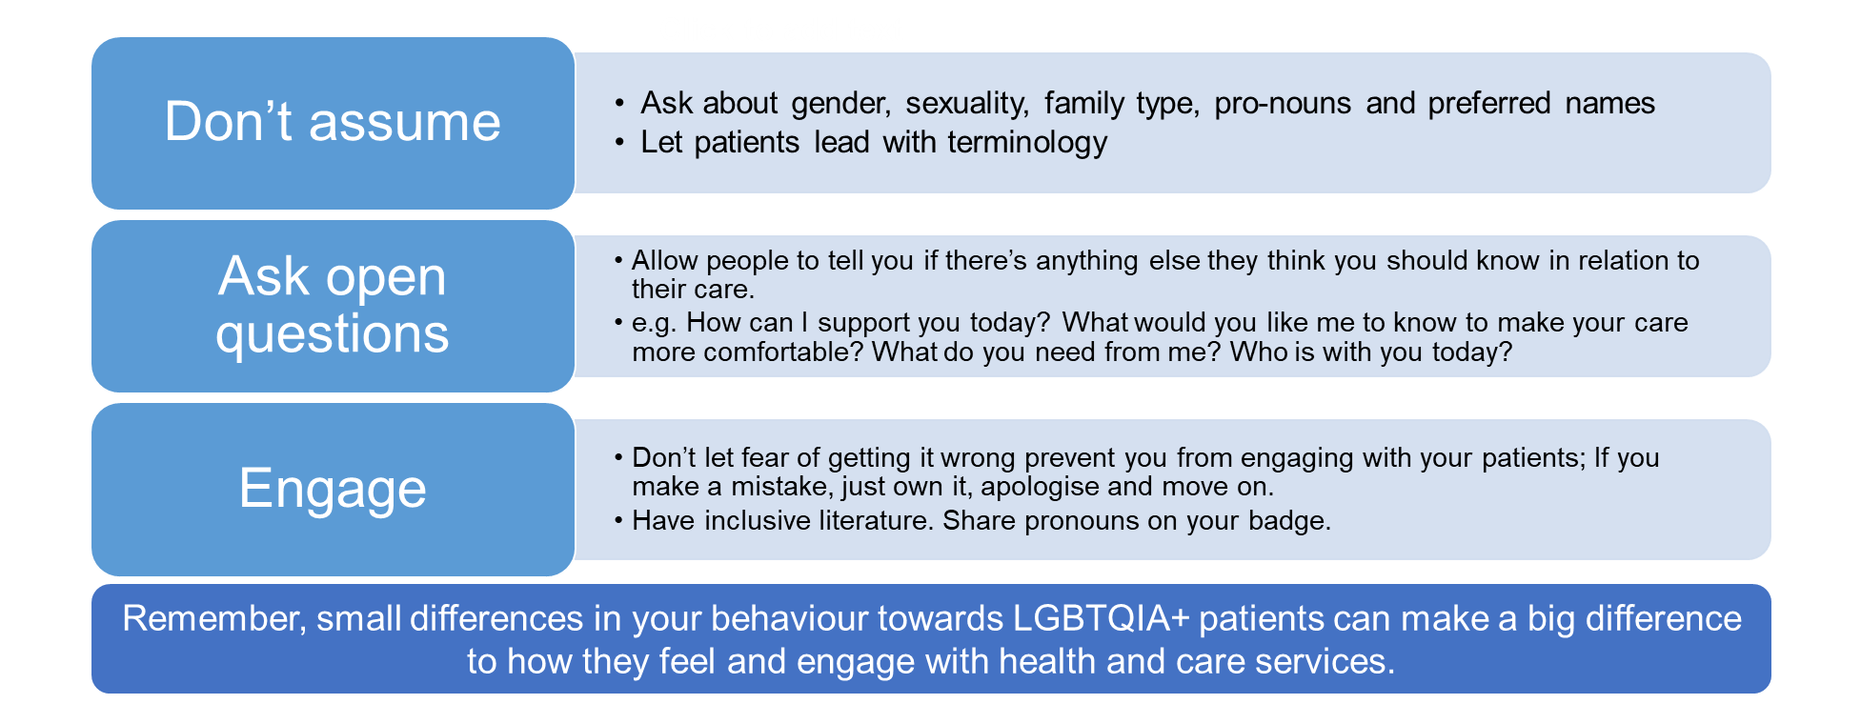
Additional support services
Scan the QR code for additional services and LGBTQ specific support


- Macmillan Cancer Support
- OUTpatients LGBTIQ+ Cancer Charity
- The Whittington Health Macmillan Information and Support Service
- NHS Talking Therapies services
- Hospice UK
- Teenage Cancer Trust
- Shine Cancer Support
- UCATS- UK Cancer and Transition Service
- LGBTQ+ Walnut

