Our Sickle Cell Emergency Department card outlines your rights as a patient, and our pledge to provide you with the best care possible.

You can:

Screenshot the card on the next page with your phone and show the screenshot to our staff at our Emergency Department.

**Or**

Scroll down to the third page to print a copy of the card to show to our staff at our Emergency Department.

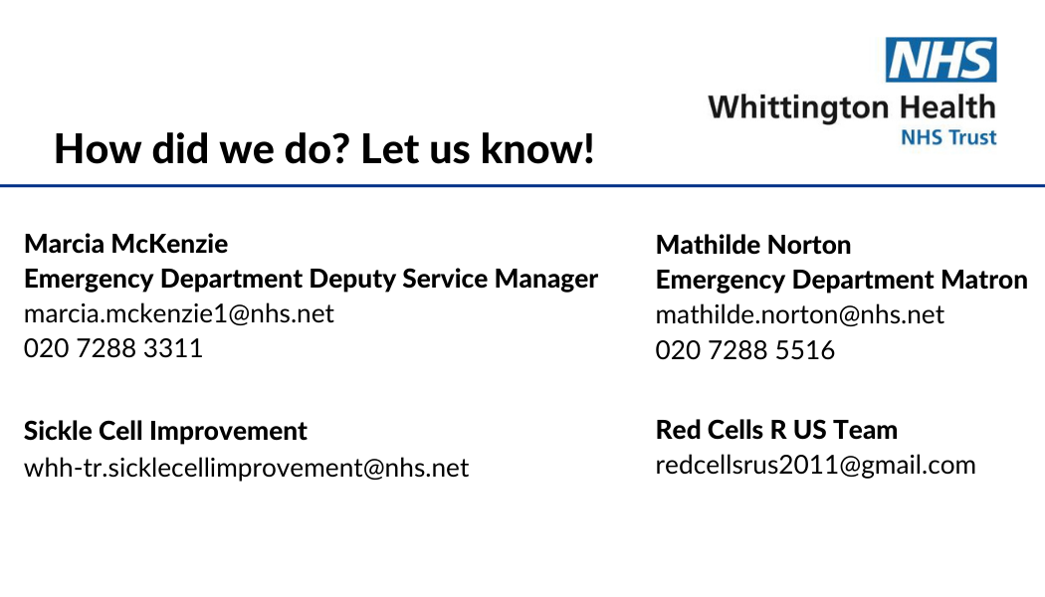

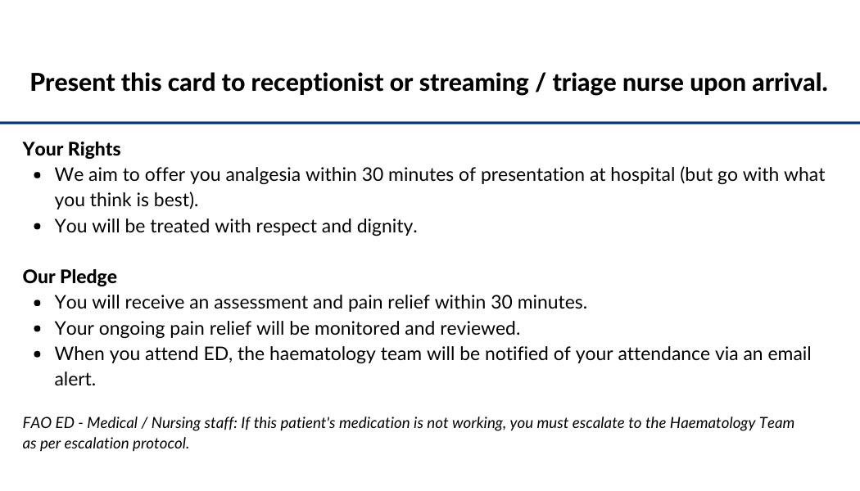

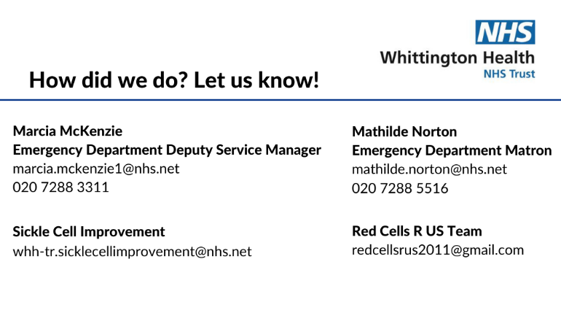

Cut out the card along the green line with scissors

Fold down the blue line.

