|  |  |  |  |  |  |  |  |  |  |
| --- | --- | --- | --- | --- | --- | --- | --- | --- | --- |
| **Child’s Details** | | | | | | | | | |
| First Name: | Click here to enter text. | | | Known as: | | | Click here to enter text. | | |
| Surname: | Click here to enter text. | | | | | | | | |
| Gender: | Choose an item. | | | Date of Birth: | | | Click here to enter a date. | | |
| NHS No.: | Click here to enter text. | | | Hospital No.: | | | Click here to enter text. | | |
| Address: | Click here to enter text. | | | | | | | | |
| Postcode: | Click here to enter text. | | | Borough of Residence: | | | Choose an item. | | |
| Home Tel No.: | Click here to enter text. | | | Child’s Mobile No.: | | | Click here to enter text. | | |
| Ethnicity: | Choose an item. | | | | | | | | |
| **Parent/Guardian Details** | | | | | | | | | |
| Mother’s Name: |  | | | | | | | | |
| Mobile No. | Click here to enter text. | | Language  spoken: | | Click here to enter text. | | | Interpreter Required?: |  |
| Father’s Name: | Click here to enter text. | | | | | | | | |
| Mobile No. | Click here to enter text. | | Language  spoken: | | Click here to enter text. | | | Interpreter Required?: |  |
| Legal Guardian: | Click here to enter text. | | | | | | | | |
| Please give details of other communication difficulties we need to know about prior to contacting the family, e.g. hearing difficulties: | | | | | | | | | |
|  | Click here to enter text. | | | | | | | | |
| **General Practitioner** | | | | | | | | | |
| GP Name: | Click here to enter text. | | | | | | | | |
| GP Address: |  | | | | | | | | |
| Postcode: | Click here to enter text. | | | Telephone Number: | | | Click here to enter text. | | |
| **Other Information** | | | | | | | | | |
| Main Diagnosis: | Click here to enter text. | | | | | | | | |
| Nursing care required / reason for referral: | | | | | | | | | |
|  | Click here to enter text. | | | | | | | | |
| Current Medication / Treatment *(e.g. TTA’s, Dressings, Enteral Feeds)*: | | | | | | | | | |
|  | Click here to enter text. | | | | | | | | |
| Supplies given *(e.g. Dressings, IV Antibiotics, etc. Has Drug Chart been given to parents?):* | | | | | | | | | |
|  | Click here to enter text. | | | | | | | | |
| Any other key information *(including any possible risks for CCN visiting, child protection concerns)*: | | | | | | | | | |
|  | Click here to enter text. | | | | | | | | |
| Date 1st Visit or Contact: |  | | | Visit / Telephone Contact: | | |  | | |
| **Other Professionals** | | | | | | | | | |
| Hospital Consultant: |  | | | | | | | | |
| Contact Details: | Click here to enter text. | | | Telephone Number: | | | Click here to enter text. | | |
| School Nurse: | Click here to enter text. | | | | | | | | |
| Contact Details: | Click here to enter text. | | | Telephone Number: | | | Click here to enter text. | | |
| Health Visitor: | Click here to enter text. | | | | | | | | |
| Contact Details: | Click here to enter text. | | | Telephone Number: | | | Click here to enter text. | | |
| Names of other Key Professionals involved *(e.g. Social Worker, Dietitian, Physiotherapist, Speech Therapist)*: | | | | | | | | | |
|  | Click here to enter text. | | | | | | | | |
| **Referred By** | | | | | | | | | |
| Name: |  | | | Designation *(e.g. Nurse, Doctor)*: | | |  | | |
| Organisation / Location *(e.g. hospital, ward, GP Practice, etc.)*: | | | | | | | | | |
|  |  | | | | | | | | |
| Telephone Number: |  | | | | | | | | |
| Have parents / guardians been informed of the referral? | |  | | | | **(N.B. Parents must be informed of the referral)** | | | |

Please note: your email address will be taken as a signature and the date of referral will be taken as the date the email was sent.

(*N.B. form should be checked and signed by a qualified member of staff*)

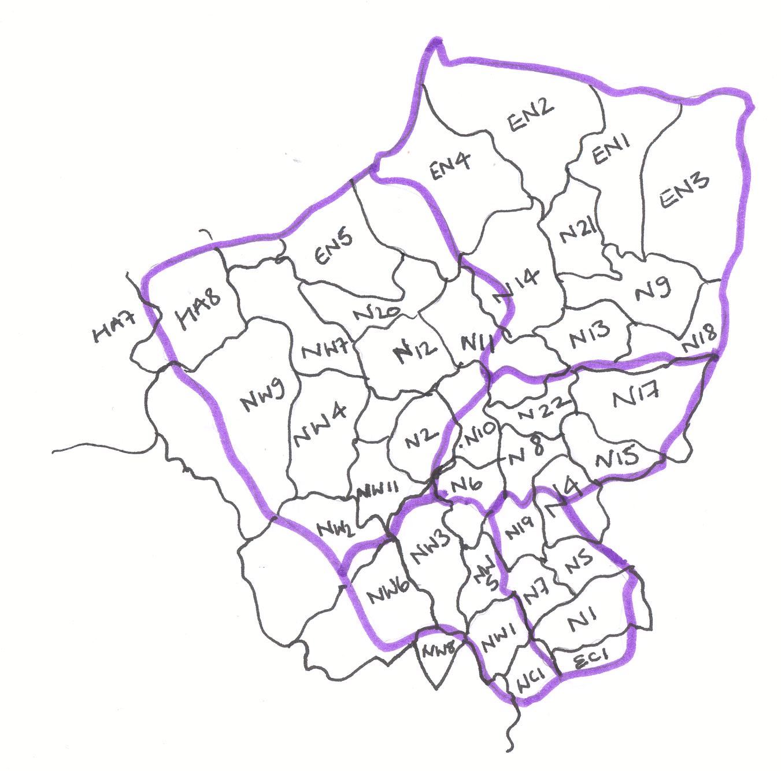

**Contact details for Community Children’s Nursing (CCN) referrals within North Central London (inside the purple boarder)**

**For a child living in:**

* **Islington** refer to the Islington CCN team. Mon-Fri 8-6, Sat & Sun 8-4. Telephone: 020 3316 1950   
  Email: whh-tr.IslingtonChildrensNursing@nhs.net
* **Camden and South Barnet** (NW2 NW11) Refer to the Royal Free Hospital CCN Team. Mon-Fri 8-6, Sat 8-4.   
  Telephone: 020 7830 2571 Email: rf.CommunityChildrensNurses@nhs.net
* **Haringey** refer to the North Middlesex Hospital CCN team. Mon-Sun 9-5. Telephone: 020 8887 3301   
  Email: northmid.ChildrensCommunityNurses@nhs.net
* **Enfield** and there post code begins with an E they should be referred to the Chase Farm Hospital Home Care Team. Mon-Sun 9-5. Telephone: 020 8375 1992 Fax 020 8375 1903 If the the postcode begins with an N they should be referred to the North Middlesex Hospital CCN team. Mon-Sun 9-5. Telephone: 020 8887 3301   
  Fax: 020 8887 2973.
* **Barnet** and they are under a consultant at Barnet Hospital refer to the Barnet Home Care Team. Mon-Sun 9-5. Telephone: 020 8216 5242 Fax: 020 8216 5244. If they are not under a consultant at Barnet Hospital, either discuss with a consultant or the Home Care Team.

**NCL Community Children’s Nursing Network**

**Islington**

## Haringey

## Hertfordshire

## Essex

**Waltham**

## Forest

**Hackney**

**Brent**

## Harrow

**Camden**

# Barnet

**Enfield**