**Speech and Language strategies for home learning**

**Visuals**

* use relevant, appropriate pictures and videos and refer to frequently to support understanding
* demonstrate and model - show as well as talk
* use gestures
* make a task checklist for the day, tick/cross off as you go

**Instructions** **and Questions**

* Simplify the wording of instructions e.g. by breaking down into individual steps
* Check understanding e.g. ask them to tell you what they have understood in their own words
* Repeat and rephrase as needed so they understand
* Encourage your child to let you know when they don’t understand
* Simplify questions – use more concrete questions initially and build up to questions which require more abstract verbal reasoning (such as ‘why’ and ‘how’ questions)

**Vocabulary**

* check understanding (ask them to use the word in a sentence)
* simplify vocabulary if needed
* teach the sounds and the meaning and review regularly
* Practise using a dictionary (online or book)
* Create a word map

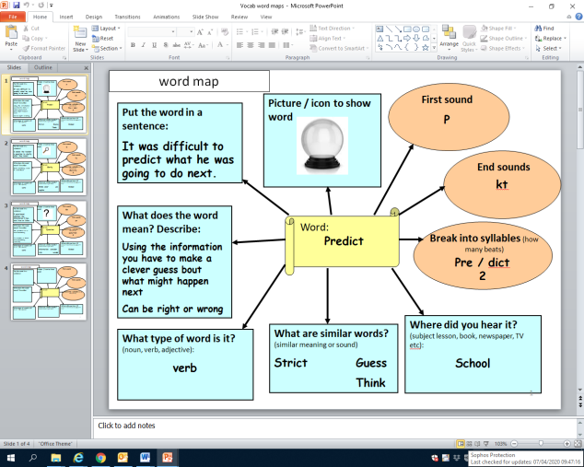

**Discussion**

Ensure you provide time to discuss and review the things you are learning about with your child. Listen to them and share thoughts and ideas.