**Workforce Disability**

**Equality Standard**

2025/26 Outcomes and Action Plan

**Introduction**

**The Development of the Action Plan**

The following action plan has been developed with input from HR Business Partners, Organisation Development Team, Workforce Systems and Analytics, the Inclusion Group, and in collaboration with our WhitAbility (disabled staff network). The action plan is also informed by concerns from the Freedom to Speak Up Guardian report and those highlighted to the inclusion team directly.   
It has been presented and agreed upon at the Trust Executive Management and Trust Management meetings. All the stakeholders will make contributions to the delivery of the action plan. As a live document, progress will be monitored quarterly, and the action plan will be updated accordingly.

**The Vison statement communicates a shared understanding of the culture we wish to achieve. It has informed our goals and strategy for pursing them.**

A place you want to come to, a place that’s fruitful and abundant with joy and laughter. It’s a safe and warm place that values and appreciates everyone’s difference.

All staff, managers and leaders enable, empower and encourage colleagues, regardless of background to be their best and to give of their best. It’s a place where we celebrate together the wonderful nature of our diversity and work together to deliver on our ambition of high-quality patient care for the people in our locality and beyond.

***Vision Statement developed by Staff Network Members & Staff.***

***Whittington Health NHS Trust***



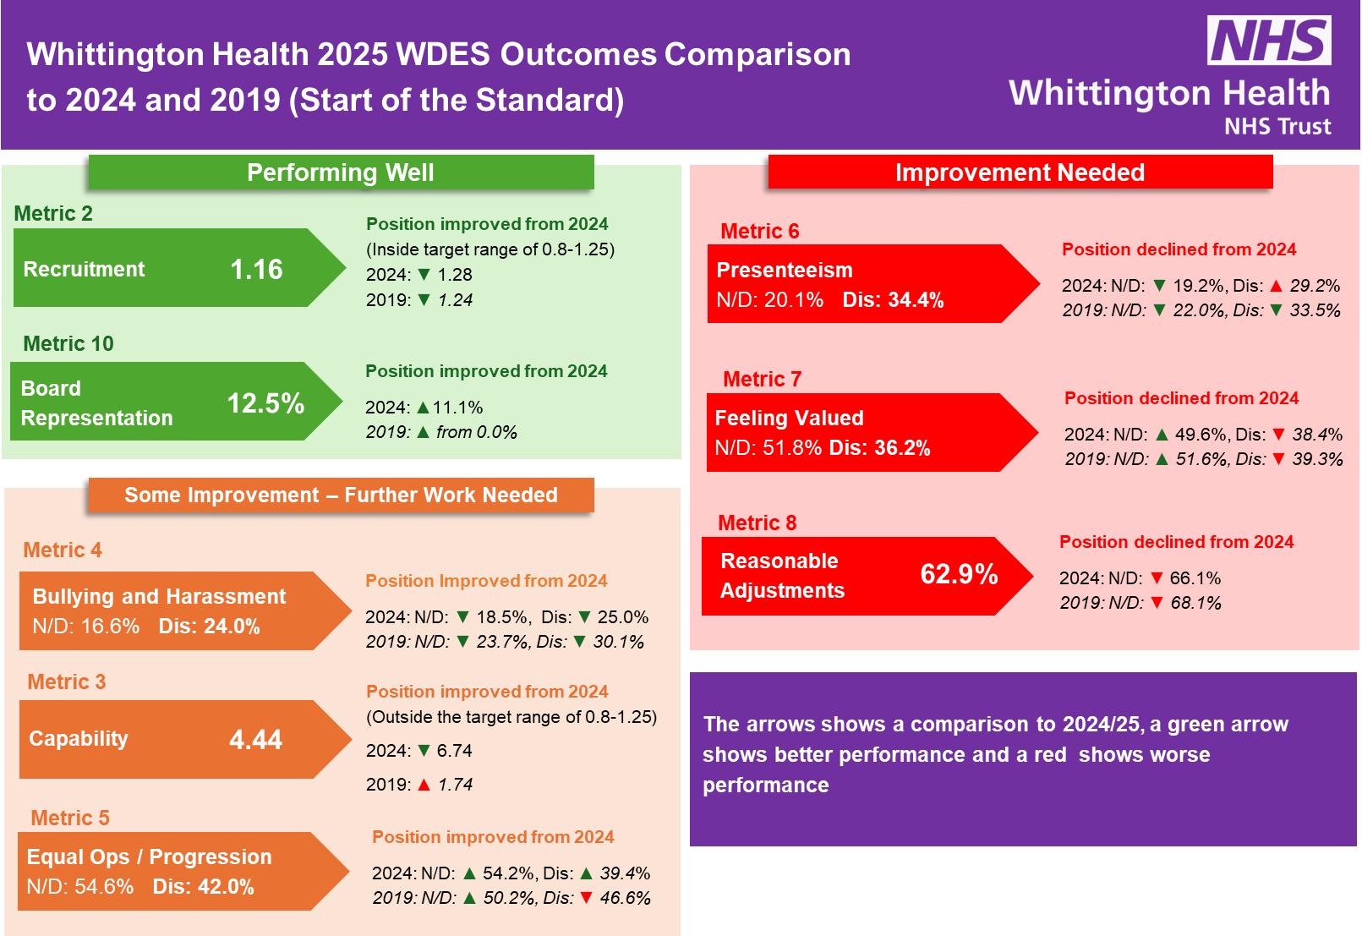In

**of the Action Plan  
Findings**

**The following areas have been identified from 2024-25 WDES as areas requiring our greatest focus:**

**Metric 1 -** Representation of Disabled staff in clinical and non-clinical roles

**Metric 5 -** Equal opportunities for career progression for Disabled staff

**Metric 6** - Presenteeism.

**Metric 7 -** Feeling valued

**Metric 8 -** Reasonable adjustments

**Areas where progress has been made but where further work is required:**

**Metric 4 -** Bullying, harassment and abuse from managers

Note:

**Metric 3 -** Disabled versus non-disabled staff entering the formal capability process. (While the data for this year highlights an area for concern, the relatively low number of processes and low declaration rate will demonstrate any representation in this metric as disproportional. This is something that has been highlighted by the national WDES Team). We will monitor the progress of this metric.

The action plan highlights the actions the Trust will be taking to address the areas for improvement highlighted above.

The following action plan has been developed with input from HR Business Partners, Organisation  **Action Plan**

|  |  |  |  |  |
| --- | --- | --- | --- | --- |
|  | Action | WDES Metrics | Owner | Completion |
| **1.** | Focused campaign to encourage declaration of equality information | 1 & 3 | EDI Lead | Ongoing |
| **2.** | Continued rollout of the reasonable adjustment guidelines and health passport programme | 6, 7 & 8 | EDI Lead | Completed |
| **3.** | Provide continued support to the WhitAbility Staff Network (Disabled Staff Network) | All Metrics | EDI Lead | Ongoing |
| **4.** | Conduct a disability pay gap audit | 1,5 & 7 | EDI Lead | Completed built into annual reporting |
| **5.** | Promote the NCL Core Manager’s Programme of Increasing Manager’s Disability Positivity | 1, 2, 3, 4, 5, 6, 7 and 8 | Joint Directors of Inclusion and EDI Lead | Ongoing |
| **6.** | Promote the NCL wide commissioned Calibre leadership development programme for disabled staff. | 1, 2, 3, 4, 5, 6, 7 and 8 | Joint Directors of Inclusion and EDI Lead | Completed – several Trust staff attended. |
| **7.** | Ongoing training for staff and managers around disability awareness and reasonable adjustments | 3, 4, 6, 7 and 8 | EDI Lead | Ongoing – training sessions monthly |
| **8.** | Promotion and development material for the Disability Support Hub | 4, 6, 7 and 8 | EDI Lead | Ongoing – Hub is published, but new materials to be produced regularly. |
| **9.** | Promotion of centralised Reasonable Adjustment Budget | 7 and 8 | EDI Lead | Ongoing – promoted through training, communications and agreement with IT. |

**informed our goals and strategy for pursing them.**