**Using Lego™ at home to support language and communication skills**

**Lego™ Therapy**

Many children love playing with Lego™ at home, and it can be used to develop a child’s language and social communication skills. Lego™ Therapy aims to develop a child’s ability to:

* Listen to and follow instructions from others
* Give instructions to others using clear, specific language
* Ask for clarification if they have not understood
* Focus on an activity when it is another’s turn
* Stay within a role which contributes to completing a project with others as a team
* Problem-solving
* Sharing and turn-taking

**What does Lego™ Therapy at home involve?**

Usually, Lego™ Therapy requires three people to take on three roles:

* Architect, or engineer. This is the person who knows what is to be built, and who gives instructions to the others.
* Supplier. Supplier listens to the instructions from the architect/engineer and makes sure the builder has the correct blocks to build with.
* Builder. The Builder receives the blocks from the supplier, and follows the architect’s instructions to build.

Siblings can join in. If there are only two of you at home, you can take out the supplier role, and instead take turns being the builder and architect/engineer.

**How do I get started?**

1. The adult gives each person a role. Sometimes children have a preference for a particular role but it is helpful for them to also learn to accept roles they

are less happy with. Focussing on the turn-taking aspect of this (“we all take turns at each role”) can help.

1. Make sure everyone knows what their role involves. Use these cue cards to explain what each role does:

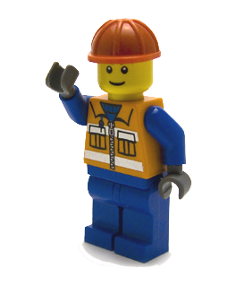**Architect/engineer**

You are the **Architect/engineer.**

Your job is to look at the picture and tell the **supplier** what bricks they need and tell the builder how they build the model.

Remember: You cannot work alone...be a team player!

**Supplier**

Your job is to listen to the architect and give the **builder** the bricks they need to build the Lego model.

Remember: You cannot work alone...be a team player!

**Builder**

You are the **builder.**

Your job is to build the Lego model with the help of the **supplier** and the **architect**.

Remember: You cannot work alone...be a team player!

1. Have a model or a picture of a Lego™ model which is to be built. You can use the manuals which often come with Lego™ sets or you can create your own model by taking a photo or series of photos on your phone (i.e. a photo of each step in the build as shown in the example below) for the architect/engineer to refer to. The structures to be built can be very simple (just a few blocks on top of each other) or very complex – adapt it to what you feel your child can do

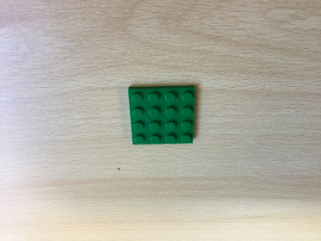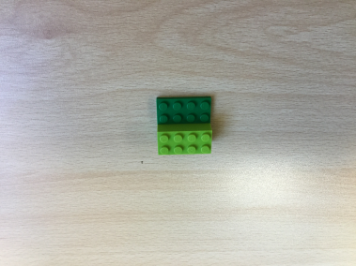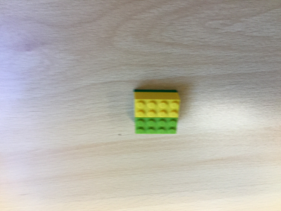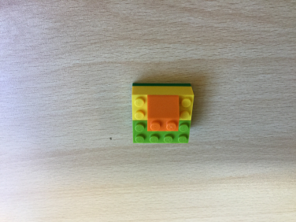

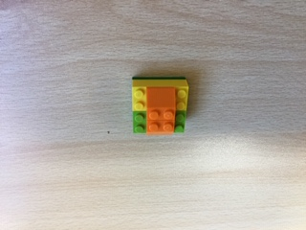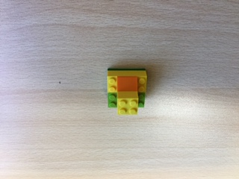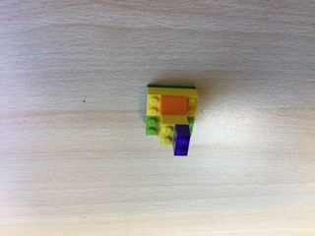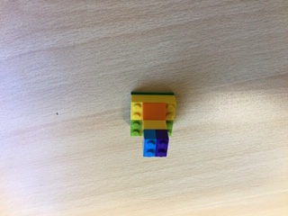

1. The architect starts with the first picture, and asks the Supplier to give the first block to the builder: “<Child’s Name (supplier)>, can you please give the flat, green square block to <Child’s Name (builder)>”
2. For the second picture, the architect asks the supplier to give the second block (in this case, the long, green block). Then the architect tells the builder where to put the second block, in this example: “<Child’s Name (builder), put the long green block on top of the square green block on the edge”
3. Keep going until the structure is built! Celebrate the success of listening to each other and working together as a team to create a model.

**Things to remember:**

Sometimes children want to use their hands to ‘show’ or ‘point’ to where to put the blocks. Instead, encourage them to use the right language, such as:

* size (big, little, thin, wide)
* shape (square, rectangle, triangle)
* colour (blue, green, yellow etc)
* children can also describe the pieces by counting the number of dots on the top (e.g. the green piece with 8 dots)
* position (on top of, next to, under, on the edge, on the side, in the middle)

You can model to your child the language they can use to describe which blocks to use, and where to put them.

Also encourage:

* Children to watch each other when it is another’s turn
* Children to ‘stay in their role’ – it can be tempting for the children who are in the architect / engineer role to jump in and try to take over if they see someone struggle, either with following the instructions or putting the pieces together. Remind them their job as the architect is to give the instructions, it is the builder’s job to build it.
* Asking for clarification when the instruction is not clear, e.g. “Which blue block? The square one or the long, thin one?”
* Having fun and enjoying working together!