Potential risk areas | Skin Assessment |  |  | Surface (equipment ) | Keep  Moving | Incontinence |  | Nutrition
 | 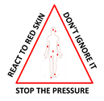 |  |  | 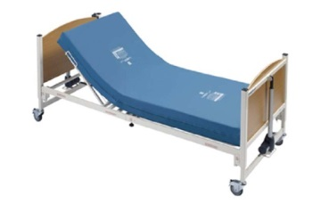 | 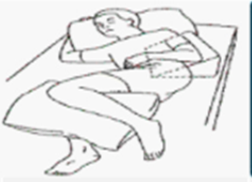 |  |  | 
Intervention  &  Actions  OBJECTIVE To engage patient, nurses, and carers in pressure ulcer prevention | - Check the skin at each vulnerable area at every opportunity  - usually where the bones lie close beneath the skin.  - Document any existing areas of skin damage including scar tissue  - Apply fingertip test to any reddened / discoloured areas and check it blanches  - If blanching does not occur – you have skin damage  - If the skin is darkly pigmented instead of looking for reddened areas look for –  - Darker areas, heat or pain, hardening of skin or overly soft skin. |  |  | - Have a current Waterlow score  - Select equipment (mattress /cushion ) according to Waterlow score and local guides lines  - Use pillows to elevate heels off the mattress and separate limbs  - Check electrical equipment is plugged in and serviced.  - Keep vulnerable areas or already ulcerated areas from lying on a firm resting surface  - Ensure glasses, oxygen tubing, other tubing, call bells, are not causing skin damage by being rested on | - Encourage patient to self-turn/stand /walk  - Explain to family, carers need for repositioning  - Provide information factsheet  - Use positional charts  - In high risk patients chair sitting time may need to be restricted to 2 hours only or even 24 hour bed rest advised with 2 hourly positional changes  - Even with air cushion and air mattress repositioning and restricted sitting time may be required in some situations  - Use the 30 degree tilt to vary and change positons  - Check pain is not preventing positon changes | - Encourage walking to toilet /commode  - Encourage assistance and frequent support with toileting  - Only use one continence pad at one time  - Request a continence assessment if the pads are not suitable  - Use skin barriers and creams that are transparent so the skin can be easily checked for any damage  - Use the opportunity of going to the toilet to check the skin on the buttocks and back of the thighs  - Encourage people to speak about any change to their bowel habit or passing urine |  | - Have a current MUST/nutrition score  - Encourage fluids  - Provide information about importance of good balanced diet  - Complete food and fluid charts if nutrition is compromised  - Refer to dietician as required  - Follow dietician or SALT care plans  - Encourage people to say if their appetite or fluid intake levels have changed  - Check the mouth/teeth and tongue are healthy  - If pressure ulcers are present then encourage high fat and protein diet
Date of assessment |  | Waterlow score | Clinicians Name |  | Clinicians signature | Client/carers name | Client/signature carers
NB: The care plan is to be discussed with the patient when the Waterlow reassessment has been undertaken.

