|  |  |  |  |  |  |  |  |  |  |
| --- | --- | --- | --- | --- | --- | --- | --- | --- | --- |
| For referrals to Wood Green please email: referrals.woodgreencdc@nhs.net  *Please note that requests have a 90-day expiry date from the referral date. Please note currently we only accept non-obstetric US requests for urinary tract, abdomen and gynae scans that follow BMUS guidelines. We offer all x-rays except OPG. We only accept patients over 18 years old. We have no facilities for transport patients.* | | | | | | | | | |
| **Patient demographics** | | | | | | | | | |
| NHS Number:Click here to enter text. | | |  |  | | |  |  |  |
| First name:Click here to enter text. | | | Last name:Click here to enter text. | | | | | | |
| Date of Birth: Click here to enter text. | | Gender:Choose an item. | | | | Ethnicity:  Choose an item. | | | |
| Address:Click here to enter text. | | | City/Town:Click here to enter text. | | | | Post Code: Click here to enter text. | |  |
| Interpreter:Choose an item. |  | Language: Click here to enter text. | | | | | 🖀Click here to enter text.  🖀Click here to enter text.  🖅 Click here to enter text. | | |
| Mobility:Choose an item. | | Any special requirements?:Click here to enter text. | | | | | | | |
| Pregnancy:Choose an item. |  | If Yes - Gestation wks:Click here to enter text. | | | | | |  |  |
| COVID:Choose an item. |  | Other Infection:Click here to enter text. | | | | | | | |
| **Referrer Details** | | | | | | | | | |
| Referrer Name:Click here to enter text. | | | | GMC #: (if applicable):Click here to enter text. | | | | | |
| Referring Practice:Click here to enter text. | | | | | | | | | |
| Date of referral:Click here to enter text. | | | Telephone #:Click here to enter text. | | | | | |  |
| **Examination Requested** | | | | | | | | | |
| Exam requested:Click here to enter text. | | | | | | | | | |
| Clinical History: Click here to enter text. | | | | | | | | | |
| Question to be answered:Click here to enter text. | | | | | **Clinical Priority**:Choose an item. | | | | |
| Wood Green CDC Contact Details:  🖀 02072885626 – Call Centre  🖅 Enquiries: enquiries.woodgreencdc@nhs.net  🖅 Referrals.woodgreencdc@nhs.net | | | | |  | | | | |

**Where you can go for your X-ray:**

**Wood Green Community Diagnostic Centre**, The Mall Wood Green (located on the ground floor between Primark and Boots), N22 6YQ — 020 7288 5626

Walk in with your referral – no appointments required.

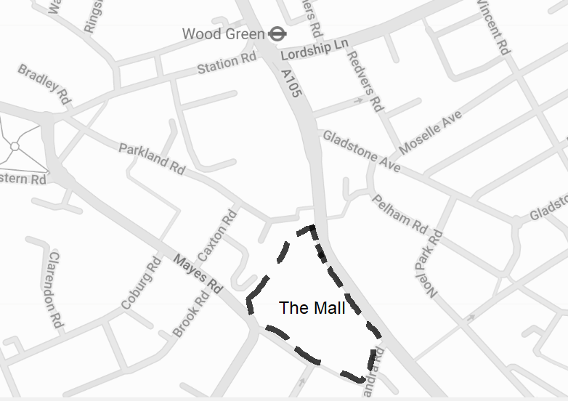Monday – Friday

9am – 6:30pm

Saturdays

9am – 4:30pm

Over 75 different buses run through Wood Green and stop directly outside the mall. The main bus routes in to Wood Green are: 29, 67, 121, 123,141, 144, 184, 221, 230, 232, 243, 329, W3 and W4.

Take the Piccadilly line to either Wood Green or Turnpike lane.

**Whittington Hospital**, Magdala Avenue, N19 5NF, 020 7288 5888

Walk in with your referral – no appointments required.

Monday – Friday

9am – 5pm

For ultrasound referrals you will receive a letter in the post with details about your appointment.